**Database: Thesis management system**

1. **Designing(Entity Relationship)ER Diagram**

Steps of Drawing ERD

1. Identify the Entities Required
2. Identify the Attributes and Primary Key for each Entity
3. Identify the Relationship needed
4. Identify the Cardinality Ratio and Participation
5. Draw the Diagram

**Thesis management system**

A student can submit one thesis. Each thesis belongs to one student and one advisor. An advisor can supervise multiple theses. All students and advisors include only one department, not multiple departments. Multiple committee members review theses. A thesis can have multiple progress reports over time.

**Step-1: Identify the Entities Required**

1. Students
2. Thesis
3. Advisors
4. CommitteeMembers
5. ProgressReports

**Step-2: Identify the Attributes and Primary Key for each Entity**

1. Students (student_id, name, email, roll, contact, department, thesis_id)
2. Thesis (thesis_id, title, abstract, status, student_id, advisor_id, submission_date)
3. Advisors (advisor_id, name, email, contact, department)
4. CommitteeMembers (member_id, name, email, contact, thesis_id)
5. ProgressReports (report_id, progress_notes, submission_date, thesis_id,)

**Step-3: Identify the Relationship needed**

* **One-to-One Relationship**
* Student $→$ Thesis (Each student has one thesis)
* **One-to-Many Relationship**
* Advisor $→$ Thesis (One advisor supervises many

thesis)

* Thesis $→$ ProgressReports (A thesis has multiple

progress reports)

* **Many-to-Many Relationship**
* Thesis $↔$ CommitteeMembers ( theses are reviewed

by multiple committee members)

**Step-4: Identify the Cardinality Ratio and Participation**

1. Student $→$ Thesis (Each student has one thesis)
2. Advisor $→$ Thesis (One advisor supervises many

thesis)

3. Thesis ProgressReports (A thesis has multiple

progress reports)

4. Thesis $↔$ CommitteeMembers (theses are reviewed

by multiple committee members)

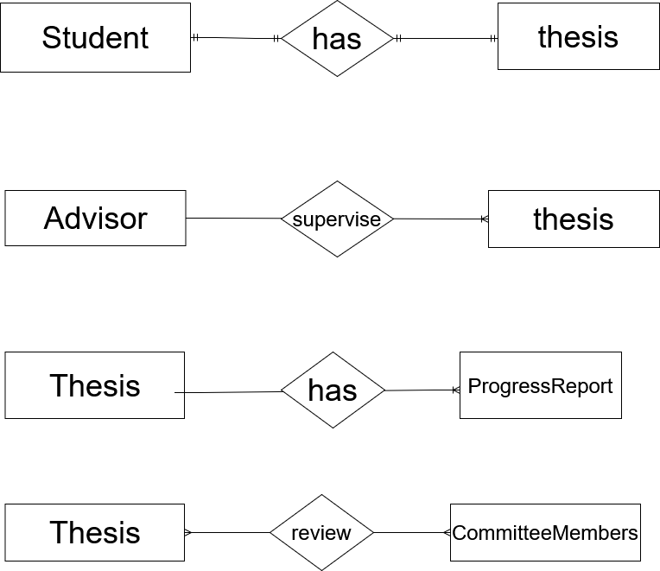

**Step-5:** Draw the Diagram

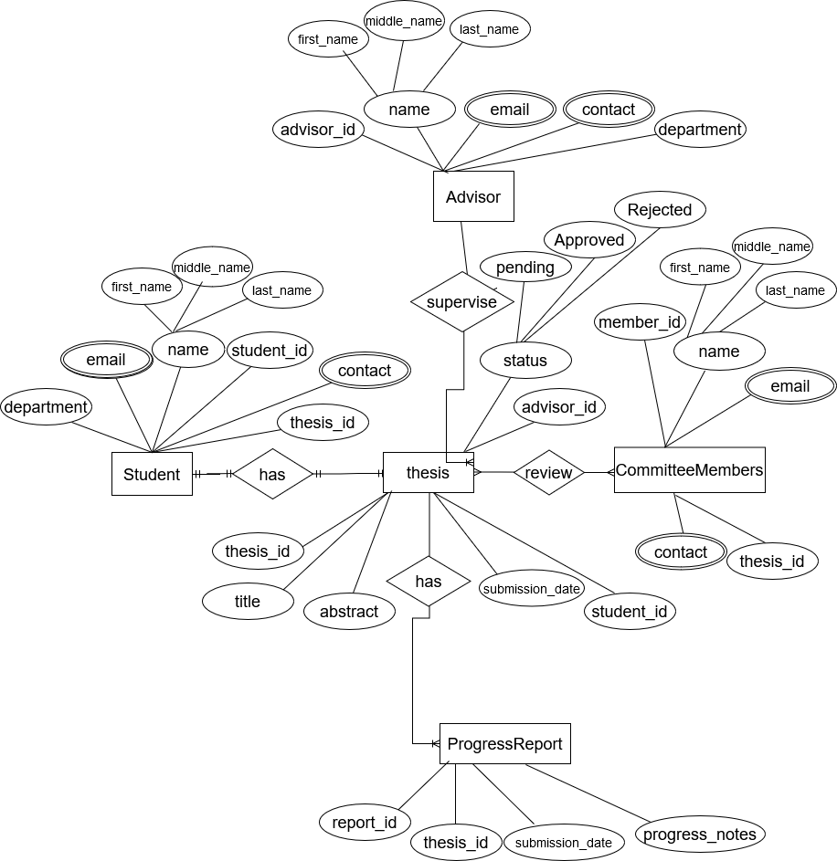

1. Reduction to database schema:
2. Students (**student_id,** name, email, roll, contact, department, thesis_id)
3. Thesis (**thesis_id,** title, abstract, status, student_id, advisor_id, submission_date)
4. Advisors (**advisor_id**, name, email, contact, department)
5. CommitteeMembers (**member_id**, name, email, contact, thesis_id)
6. ProgressReports (**report_id**, progress_notes, submission_date, thesis_id,)
7. **Implementing the database in MySQL:**

**All tables with sample data:**

Students (**student_id,** name, email, roll, contact, department, thesis_id)

|  |  |  |  |  |  |  |
| --- | --- | --- | --- | --- | --- | --- |
| **student_id** | **name** | **email** | **roll** | **contact** | **department** | **thesis_id** |
| **1** | **Md Shohan** | **sahunshohan@gmail.com** | **20-PHY-069** | **01738661570** | **Physics** | **1** |
| **2** | **Sakib** | **sakib@gmail.com** | **20-PHY-10** | **01765432845** | **Physics** | **2** |
| **3** | **Nayon** | **nayon@gmail.com** | **20-PHY-45** | **01567423834** | **Physics** | **3** |
| **4** | **Al Amin** | **alamin@gmail.com** | **20-PHY-30** | **01367282883** | **Physics** | **4** |
| **5** | **Sabbir** | **sabbir@gmail.com** | **20-PHY-24** | **01745678722** | **Physics** | **5** |

Advisors (**advisor_id**, name, email, contact, department)

|  |  |  |  |  |
| --- | --- | --- | --- | --- |
| **advisor_id** | **name** | **email** | **contact** | **department** |
| **1** | **Dr Md Mahfuz Alam** | **mahfuzalam@gmail.com** | **01789534536** | **Physics** |
| **2** | **Dr Md Khorshed Alam** | **khorshedalam@gmail.com** | **01567682882** | **Physics** |
| **3** | **Dr Md Lokman Hossain** | **lokmanhossain@gmail.com** | **01767682882** | **Physics** |

Thesis (**thesis_id,** title, abstract, status, student_id, advisor_id, submission_date)

|  |  |  |  |  |  |  |
| --- | --- | --- | --- | --- | --- | --- |
| **thesis_id** | **title** | **abstract** | **status** | **student_id** | **advisor_id** | **submission_date** |
| **1** | **Semiconductor device** | **This research focuses on the design, fabrication, and performance analysis of a novel semiconductor device aimed at improving efficiency and reliability.** | **Pending** | **1** | **1** | **2025-01-26** |
| **2** | **Electromagnetism** | **This thesis explores key principles of electromagnetism, including Maxwell’s equations, electromagnetic wave propagation, and their applications in modern technology.** | **Pending** | **2** | **2** | **2025-01-23** |
| **3** | **Astrophysics** | **This thesis investigates [specific topic], using observational data and theoretical modeling to explore [key research focus.** | **Approved** | **3** | **2** | **2025-01-20** |
| **4** | **Quantum Computing** | **Quantum computing is an emerging field that leverages the principles of quantum mechanics to perform computations beyond the capabilities of classical computers.** | **Approved** | **4** | **3** | **2025-01-24** |
| **5** | **Biomedical Physics** | **Biomedical physics is an interdisciplinary field that applies principles of physics to biological and medical sciences. This field plays a crucial role in advancing medical diagnostics.** | **Rejected** | **5** | **3** | **2025-01-19** |

CommitteeMembers (**member_id**, name, email, contact, thesis_id)

|  |  |  |  |  |
| --- | --- | --- | --- | --- |
| **member_id** | **name** | **email** | **contact** | **thesis_id** |
| **1** | **Asaduzzman** | **asad@gmail.com** | **01757357352** | **1** |
| **2** | **Asaduzzman** | **asad@gmail.com** | **01557357352** | **2** |
| **3** | **Arif** | **arif@gmail.com** | **01357357352** | **3** |
| **4** | **Kamrul** | **kamrul@gmail.com** | **01547357352** | **4** |
| **5** | **Kamrul** | **kamrul@gmail.com** | **01767357352** | **5** |

ProgressReports (**report_id**, progress_notes, submission_date, thesis_id)

|  |  |  |  |
| --- | --- | --- | --- |
| **report_id** | **progress_notes** | **submission_date** | **thesis_id** |
| **1** | **Completed initial simulations for device performance analysis.** | **2025-01-29** | **1** |
| **2** | **performance nearly excellent** | **2025-01-29** | **1** |
| **3** | **Magnet produced by initial simulations** | **2025-01-30** | **2** |
| **4** | **performance nearly good** | **2025-01-30** | **2** |
| **5** | **Completed initial simulations for experimental analysis.** | **2025-01-31** | **3** |
| **6** | **performance nearly**  **bad** | **2025-02-01** | **4** |
| **7** | **Established experimental setup for [experiment/simulation]** | **2025-02-03** | **5** |

